# Society Issue Tracker

Project Group : Parekh Manav

**Database tables :**

**1. admin**

* admin_id INT(11) NOT NULL (Primary key)
* admin_email VARCHAR(255) NOT NULL
* admin_password VARCHAR(255) NOT NULL
* role ENUM('admin') NOT NULL DEFAULT 'admin'

**2. feedback**

* feedback_id INT(11) NOT NULL (Primary key)
* issue_id INT(11) NOT NULL (Foreign key reference to issues.issue_id)
* giver_type ENUM('User', 'Secretary') NOT NULL
* giver_id INT(11) NOT NULL (ID of user or secretary who gave feedback)
* feedback_text TEXT NOT NULL
* created_at TIMESTAMP NOT NULL DEFAULT CURRENT_TIMESTAMP

**3. issues**

* issue_id INT(11) NOT NULL (Primary key)
* reporter_type ENUM('User', 'Secretary') NOT NULL
* reporter_id INT(11) NOT NULL (ID of user or secretary who reported issue)
* category ENUM('Personal', 'General') NOT NULL
* title VARCHAR(255) NOT NULL
* description TEXT NOT NULL
* location VARCHAR(255) DEFAULT NULL
* image VARCHAR(255) DEFAULT NULL
* status ENUM('Pending', 'In Progress', 'Resolved', 'Rejected') NOT NULL DEFAULT 'Pending'
* created_at TIMESTAMP NOT NULL DEFAULT CURRENT_TIMESTAMP

**4. secretary**

* secretary_id INT(11) NOT NULL (Primary key)
* sname VARCHAR(255) NOT NULL
* semail VARCHAR(255) NOT NULL
* spassword VARCHAR(255) NOT NULL
* role ENUM('Secretary') NOT NULL DEFAULT 'Secretary'
* location VARCHAR(255) DEFAULT NULL

**5. user**

* user_id INT(11) NOT NULL (Primary key)
* uname VARCHAR(255) NOT NULL
* uemail VARCHAR(255) NOT NULL
* upassword VARCHAR(255) NOT NULL
* role ENUM('User') NOT NULL DEFAULT 'User'
* location VARCHAR(255) DEFAULT NULL

**6. issue_logs**

* log_id INT(11) NOT NULL (Primary Key)
* issue_id INT(11) NOT NULL (Foreign Key → issues.issue_id)
* updated_by_type ENUM('User','Secretary') NOT NULL
* updated_by_id INT(11) NOT NULL
* action VARCHAR(255) NOT NULL
* old_value TEXT DEFAULT NULL
* new_value TEXT DEFAULT NULL
* created_at TIMESTAMP NOT NULL DEFAULT current_timestamp()

**7. notifications**

* notification_id INT(11) NOT NULL (Primary Key)
* receiver_type ENUM('User','Secretary') NOT NULL
* receiver_id INT(11) NOT NULL
* message TEXT NOT NULL
* is_read TINYINT(1) DEFAULT 0
* created_at TIMESTAMP NOT NULL DEFAULT current_timestamp()

ER-DIAGRAM

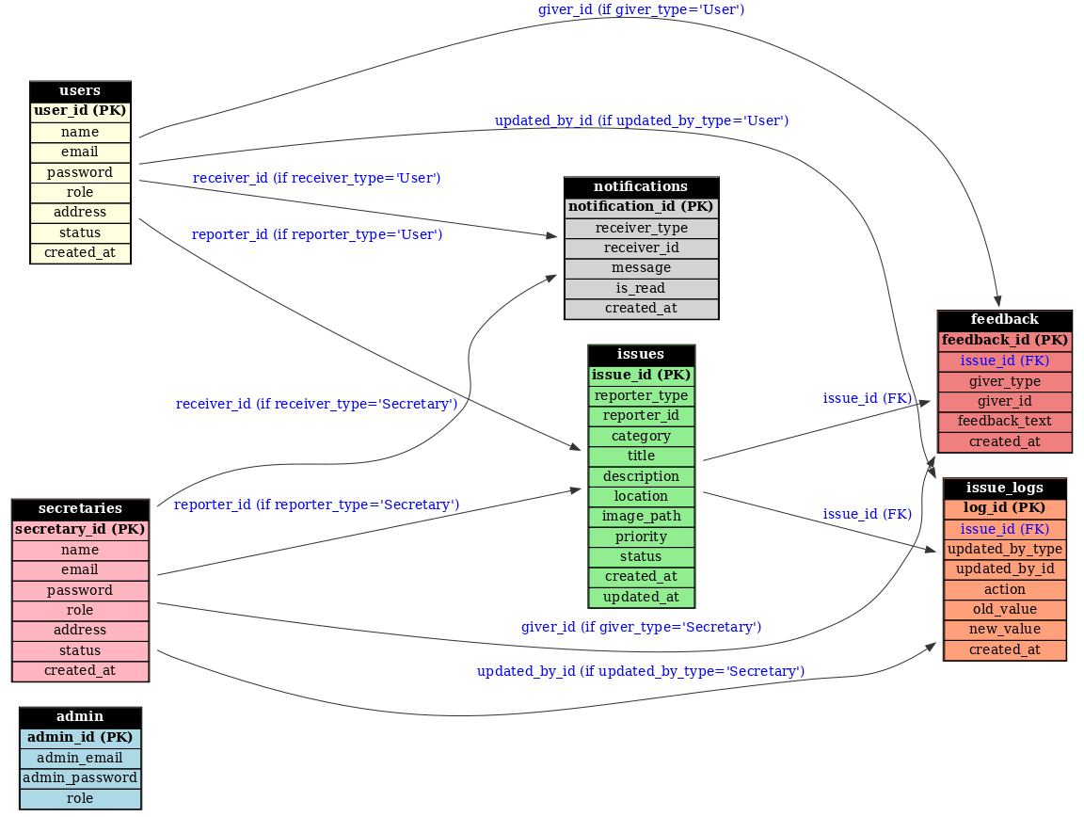

DATABASE DESIGNER

